

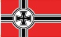
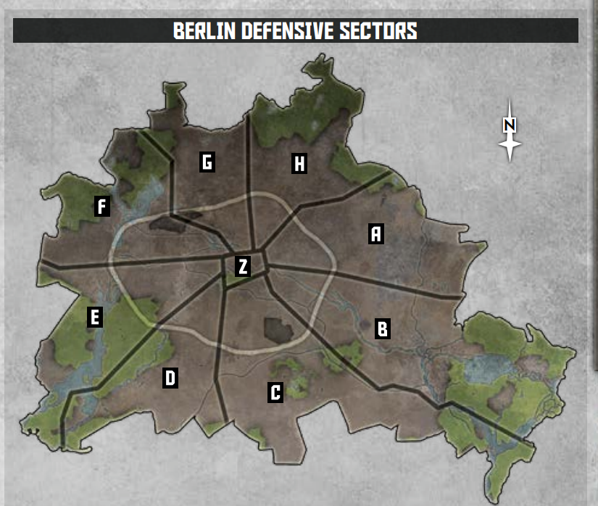

Sector | German Points | Soviet Points | Allied Points
A | 1 | 0 | 0
B | 1 | 0 | 0
C | 1 | 0 | 0
D | 1 | 0 | 0
E | 1 | 0 | 0
F | 1 | 0 | 0
G | 1 | 0 | 0
H | 1 | 0 | 0
Z | 5 | 0 | 0

