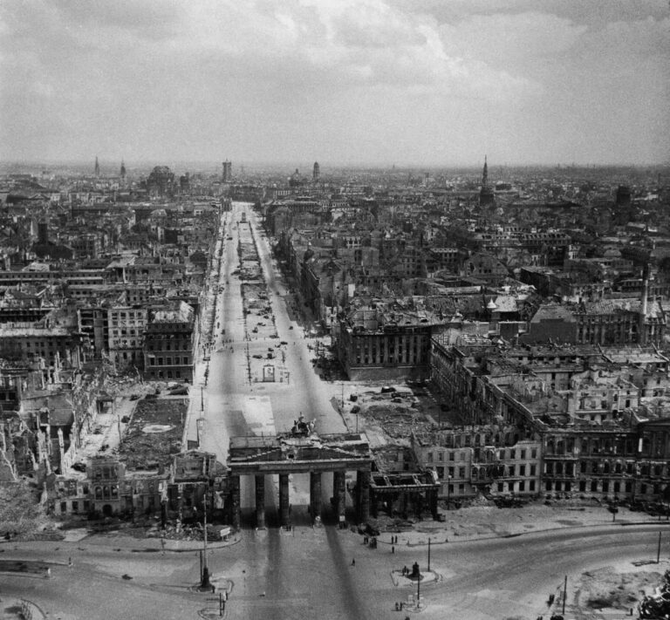
Firestorm: Berlin

Length: 3 Rounds
- Allies
  - British
    - Nachtjaeger
    - Bulge
  - American
    - Remagen
    - Bulge
  - Soviets
    - Berlin
    - Desperate Measures
    - Red Bear
- Axis
  - Grey Wolf
  - Ardennes Offensive
  - Desperate Measures
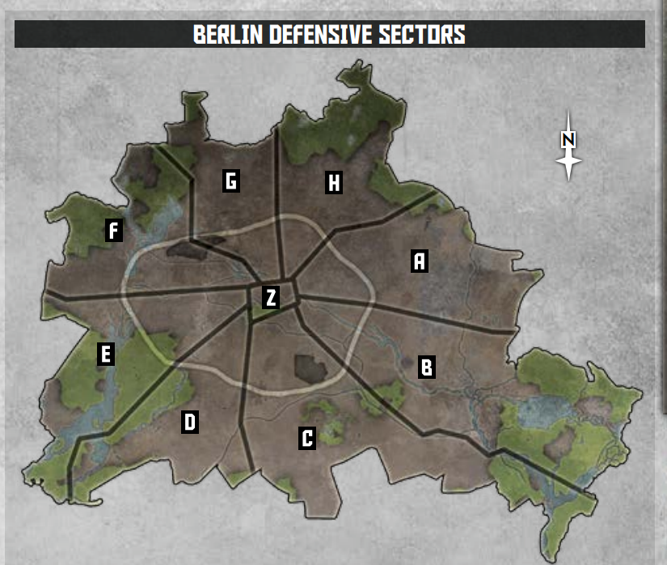
  - Berlin
Figure 1: Courtesy of Battlefront - 3rd ed. Berlin Book

Process:
For this campaign each player should play one game against each member of the opposing team. After all games are played the round is over. If any player is unable to make time to get a game in against a player their opponent may play a game against any other member of the opposing team.
To fight a battle players roll a dice, on a 3+ the allies may select a location to attack, on any other result the Germans may do so. The player who wins the roll-off must select an area to attack that they do not control. Players may not select area Z to attack unless they are a German player or they control an adjacent territory. The Germans are considered to hold every starting territory with an initial score of 1, with the exception being Z which they hold with a score of 5. After each battle players will add their scores to the designated territory with Germans winning ties. In each battle the side that chooses the location is the attacker.
Aces –
Players may select a tank or infantry Ace to use during the campaign. Players may only select one of each type but are not required to use them in every battle, Aces will level up at the beginning of each round. Ace teams take the place of the normal 1ic command team. Players must pay the appropriate cost for the equipment their unit uses and must use the same equipment in every battle.
Players may take an ace in any detachment that allows that unit to normally be used (i.e. a SMG command team may be used in any company that has a spot for such a unit. Players may scrap their old ace and select a new one at any time, but that unit must select their ace upgrades treating the current round as the first round for bonus.
Winning the campaign
At the end of third round the points for each sector. The team (Uk/USA/Soviets/Germans) that controls the greatest number of territories is the winner.
Playing a Game
Before the players set up terrain, they must generate a mission using one of several ways:
- The players may agree on a mission beforehand. Or they may agree on certain aspects of a mission beforehand: Prepared Positions vs Meeting Engagement etc.
- Players may randomly generate a mission by first rolling for a Prepared Positions or Meeting Engagement mission, then rolling for the exact mission.
  - After the mission is rolled either player may reject the mission.
    - If it is because it is the same mission, the player just played a new mission is generated.
    - However, if they simply dislike the mission, their opponent generates 2 new missions and picks the one they prefer. Re-rolling duplicates either of the previous mission or on the die.

Post Game Rewards
- Once the game is finished each player may generate rewards for playing the game. Players generate a reward by rolling a die equivalent to the Tier Table: Tier 1: D12, Tier 2 D10, Tier 3 D6. These rolls should be made in the discord server. If a player rolls a duplicate reward, they may re-roll that die.
  - The winner generates 2 rewards from their choice of tier based on the turn
  - The loser generates 1 reward as above.
- All players are limited to having a maximum of 2 rewards at any time; however, they may swap rewards with newly generated ones after each battle. Players play with an open hand and should record their rewards on the Berlin Rewards sheet. Once a reward has been used it is discarded.
The Reward Table can be found here:
https://docs.google.com/spreadsheets/d/1EcQ2jOzzzirZB2xk11Pktsh89ABncGsUfD2OOUeDFbE/edit?usp=sharing

Mission Table
Die Roll | 1 | 2 | 3 | 4 | 5 | 6 | 7 | 8 | 9 | 10
Meeting Engagement (1-3) | Free-For-All | Dust Up | Scouts Out | Probe | Out Maneuvered | Bypass | Gauntlet | Spearhead | Valley of Death | Vanguard
Prepared Positions (4-6) | Fighting Withdrawal | Surrounded | Breakthrough | No Retreat | Killing Ground | Hold the Pocket | Hasty Attack | Encirclement | Cornered | Bridgehead

- When using the 4th edition missions, 3rd edition players should ignore the following bullet points
- Players should not place ranged in markers
- Players should ignore the minefields

